Physics 20 Lesson 19H Banked Curves

# banked carForces on banked curves

The banking of curves can reduce the chance of skidding because the normal force acting on the car will have a component towards the center of the circle, thus reducing or eliminating the need for friction. In fact, for a given angle of banking, there will be one speed for which no friction force is required. In this case, there are only two forces acting on the car, Fg and FN.

Resolve FN into x and y components.

Note: 1) FN ≠ Fg

2) θ = θ

Since

cosθ = -Fg / FN

then

FN = -Fg / cosθ

FN

(FN = Fg cos θ)

θ

θ

Fg

FNsin θ

FN cos θ

FN sinθ supplies the centripetal force necessary to negotiate the curve, and Fg = FNcosθ since the car does not accelerate vertically.

1. Fg= -FN cosθ

FN = -Fg / cosθ

FN = (-9810 N / cos 15°)

FN = 10156.1 N

## Sample Problem

A 1000 kg car travels around a frictionless curve of radius 100 m. If the curve is banked at 15.0° to the horizontal, what is the maximum speed that the car can safely round the curve?

3. Fc = mv2/r

v2 = Fcr/m

v2 = (2628.6 N) (100 m)

1000 kg

v2 = 262.9

v = 16.2 m/s

2. Fc = FN sinθ

Fc = (10156.1) sin (15°)

Fc = 2628.6 N

FC

FN

Fg = mg

= (1000 kg)(-9.81 m/s2)

= -9810 N

15°

15°

100 m

The banking angle of the road, θ, is chosen so that the horizontal component of the normal force provides the centripetal force for a particular posted speed, called the design speed.

Often, highways use banked curves so that a car, without friction, and regardless of its mass, can round the curve safely at the posted speed.

Here, only Fg and FN act. So FNet = Fg +FN and Fc = Fg + FN

FN

Fg

θ

Fg

FN

Fnet = Fc

θ

To calculate the banking angle:

tanθ = Fc = mv2/r = v2

Fg mg rg

## Sample Problem

A car must round a curve of radius 475 m safely at a seed of 79 km/h. What is the angle at which the curve must be banked?

v = 79 km/h = 21.94444 m/s

tan θ = v2/rg = (21.94444m/s)2/475 m X 9.81 m/s2

θ = 5.9°

The same principle may be applied to other situations. For instance, in order for a plane to make a turn it must also bank its wings with respect to the ground. This action allows some of the lift force on the wings to be translated into a centripetal force, thus allowing the plane to make a sharper turn.

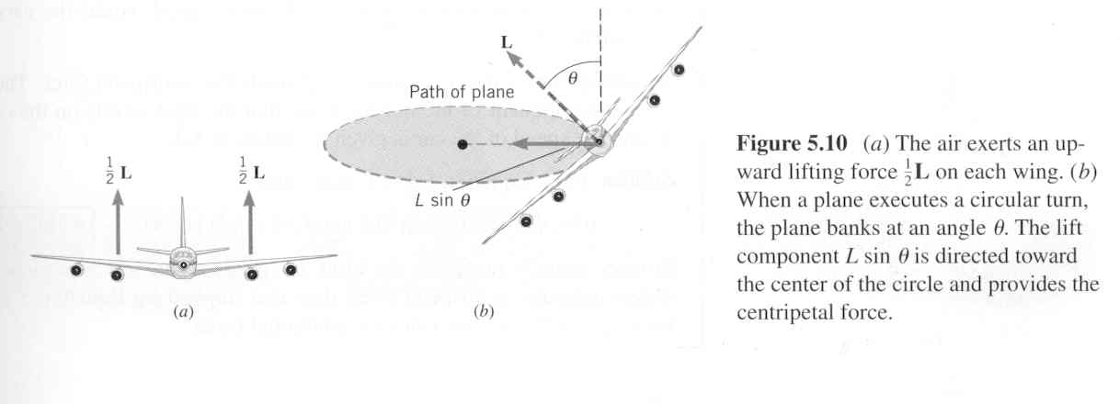

Complete the attached assignment.

### Physics 20H Banked Curves

1. What is the maximum speed a car is able to round a 125 m curve in a highway under very icy conditions (friction is negligible) if the banking angle is 18°?
2. A 745 m curve on a racetrack is too banked for cars travelling at 90 m/s. At what angle should it be banked if it is going to be used under very icy conditions?
3. A car rounds a very icy curve in the highway that is banked at an angle of 16°, while travelling at a speed of 100 km/h. What is the maximum radius of the curve?
4. A car travels on a circular banked track of radius 300 m and having a banked angle of 22°. What is the minimum time for one lap of the track if the car does not rely on friction to hold it on to the track?
5. A car is required to round a curve of radius 50 m banked at an angle of 16°. If the 1200 kg car is travelling at 70 km/h, will frictional force be required? If so, how much, and in what direction?
6. A car rounds a curve of radius 50 m at a speed of 50 km/h.
7. What is the banked angle so that friction is not required?
8. If the same angle is used for a car travelling at 90 km/h, what minimum coefficient of friction is necessary for the car not to skid?